FULL MOUTH REHABILITATION  
CLINICAL PRINCIPLES AND TECHNIQUES

A 3 day course that will help you understand and observe the occlusal disease process better, it’s a must-do course for all practitioners since comprehensive management of occlusal aspects is the need of the hour in clinical dentistry. It’s designed to help you identify and diagnose occlusal problems and also learn the appropriate protocols and armamentarium to restore mutilated dentitions to their former glory. This course will take you through every step involved in dealing with such clinical cases, right from start to finish. It’s important to know the contemporary treatment planning while restoring teeth with generalized or localized wear and yet being conservative with newer materials and minimal tooth preps.   
  
At the end of the course each participant will:

* Learn to identify occlusal problems in the natural dentition
* Stand the functioning of the TMJ and muscles of mastication
* Be proficient in programming a semi adjustable articulator
* Integrate form and function with beauty
* Understand sequencing of treatment in complex rehabilitations
* Draw a road map of treatment plan of complex cases and execute each step as per the current standards of excellence in dentistry

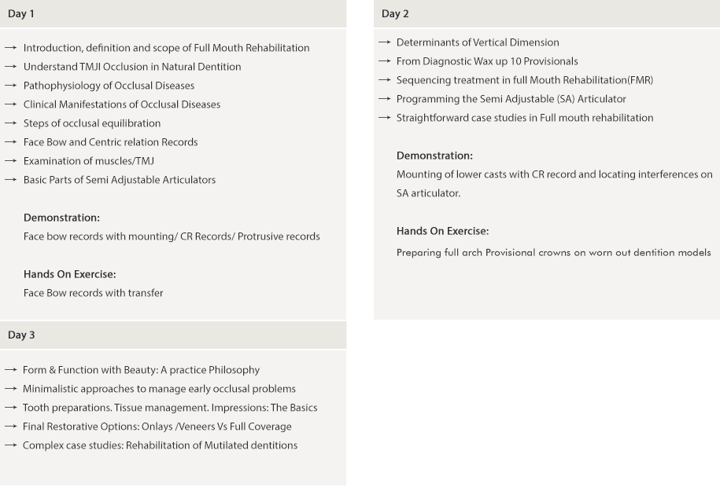

Faculty

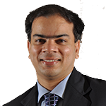

Dr. Ali Tunkiwala  
(M.D.S Prosthetic Dentistry)

With degrees and commendations from highly reputed colleges, a Diplomate Status of the International Congress of Oral Implantologists, a Fellowship status of the Indian Society of Oral Implantology and an Accredited Status by the American Academy of Cosmetic Dentistry.

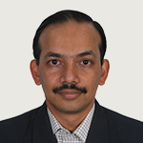

Dr. Sharat Shetty  
M.D.S Prosthetic Dentistry)

Dr. Sharat Shetty has graduated from the Government Dental College and Hospital, Mumbai and completed his Masters in Prosthetic Dentistry from the same institute.He’s a Fellow of the Indian Society of Oral Implantologists (lSOI ) and International Congress of Oral lmplantologists (lCOI) and a Diplomate of ICOL.